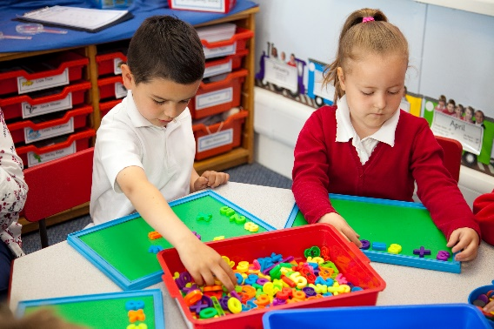

Many schools are adopting a teaching for mastery approach in mathematics. The starting point for a school is usually Year 1 and then thought is given as to how the approach is built across KS1 and KS2. Schools naturally want to consider the teaching of mathematics in Reception and how the transition to Year 1 can best support children’s learning.

The Work Groups in this project will start by exploring best practice in Early Years and how the principles might build a secure foundation in mathematics for transition into a teaching for mastery approach in Year 1. It will consider the curriculum - what children need to know and understand; approaches to planning and the inclusion of all children; and appropriate resources and contexts for effective learning.

|  |
| --- |
| Overview |

Text here

**Who is this for?**

This project is aimed at schools who are already committed to teaching for mastery and have previously engaged in a Maths Hub Teaching for Mastery Work Group. A pair of teachers should attend from each school: a Reception teacher and the teacher leading on teaching for mastery within the school. One of the sessions will be aimed at senior leaders within the school, and the headteacher or deputy head should attend this session.

**What is involved?**

Work Groups in this project will typically include three to four days of input across the academic year. How this is allocated will depend on the needs of the participants in the Work Group.

Participants are also expected to engage in research as part of their independent learning through the duration of the project. Specific gap tasks will be set, to allow participants to develop aspects of their learning in their own provision, enable sharing of practice, and allow for further developments to be made across the Work Group.

Intended Outcomes

Participants in this project will:

* develop an understanding of a key aspect of effective Early Years maths pedagogy
* understand the principles of the NCETM teaching for mastery approach, and how these can be applied appropriately within the context of an Early Years setting
* identify and implement effective Early Years pedagogies in their own provision, and gain insight into how they will support children in maths learning as they move to Year 1
* promote a positive attitude towards maths, so that all children are seeking out maths in their environment, demonstrating a willingness to ‘have a go’, and can communicate these ideas.

Early Years: Supporting effective transition from Reception to Year 1

**The wider context**

The Maths Hubs Network, across England, works on national projects by running local collaborative Work Groups of teachers around national maths education priority areas. One such priority is to embed maths teaching for mastery across primary schools. This network project exists to support effective development of teaching for mastery in both Early Years and KS1.

Work Groups use a common evaluation process, which collectively provides a body of evidence on the project’s outcomes. Your participation in this Work Group will contribute to your own professional learning, and that of your colleagues, as well as contributing to the improvement of maths education at a national level.

**Expectations of participants and their schools**

As this is CPD in the form of a Work Group, participants will be expected to carry out tasks beyond the face-to-face time. They should also be aware that as a Work Group they are developing new knowledge and contributing to a body of knowledge, so should be willing to share their findings more widely.

Participants will be expected to attend all workshops. Schools will be expected to release participants for the days required and to support them in providing time for collaborative work and gap tasks.

**If you’re interested, what next?**

Please email [NNWmathshub@queenkatherine.org](mailto:NNWmathshub@queenkatherine.org) to register your interest

**Who is leading the Work Group?**

To be confirmed

**Funding**

There is no cost to schools for this work group and all sessions and resources are free of charge.