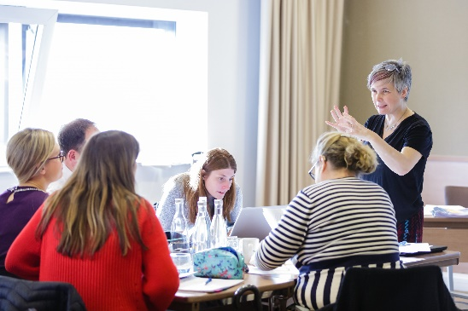

Teachers from different phases will work together in this Work Group, to improve communication between Key Stages 2 and 3. They will have the overall aim of improving continuity of learning by pupils in the four years between Years 5 and 8. Participants in this project will take an aspect of the mathematics curriculum or a pedagogical approach as the focus for their work (hubs to customise as appropriate here) and develop a consistent approach to it through discussion, joint lesson design and delivery, observation and the development of documentation to support continuity.

|  |
| --- |
| Overview |

Text here

**Who is this for?**

This project is for KS3 secondary maths teachers and KS2 primary teachers. Each Work Group will ideally consist of pairs of teachers, from linked, or neighbouring, primary and secondary schools, working together to develop a shared understanding of the teaching that gives the best chance of pupils progressing steadily in their mathematical understanding between Years 5 and 8.

**What is involved?**

Work Groups will meet several times during the year, with participants engaging in gap tasks at their own schools and at other schools between meetings. Meetings and gap tasks may include shared observation, lesson study, collaborative planning using shared models and representations, production of shared progression documents. In previous years, Work Groups have found it helpful to use multiplicative reasoning as a vehicle for exploring curriculum and pedagogical continuity.

Intended Outcomes

* Participant teachers will gain a deeper knowledge and understanding of progression in mathematical learning between Years 5 and 8, and, in parallel, a clearer understanding of the teaching approaches and pupil experiences that best serve that purpose, particularly in the ‘other’ school phase
* Participant teachers will further their experience and understanding of how consistent use of resources, representations and structures can be used to help pupils develop sound mathematical understanding
* Teachers will develop shared approaches to planning and delivery of the mathematics curriculum across KS2 and KS3
* Pupils will demonstrate improved confidence and engagement in maths at KS2 and KS3.

Year 5 to 8 Continuity

**The wider context**

Collectively, the network of Maths Hubs across England work on projects around national maths education priority areas. One of those priorities centres on primary pupils, within a teaching for mastery context, developing the deep knowledge and understanding they need to be fully prepared for the secondary mathematics curriculum. Another centres on the development of teaching for mastery in secondary schools. This Work Group addresses both these priorities.

Each Maths Hub participating in a national project runs a local Work Group, where teachers come together over a period of time to work on areas defined by the project. All Work Groups are subject to a common evaluation process, which collectively provides a body of evidence on the project’s outcomes. So, your participation in this Work Group will contribute to your own professional leaning, and that of your school colleagues, as well as making a contribution to the improvement of maths education at a national level.

level.

**If you’re interested, what next?**

Please email [NNWmathshub@queenkatherine.org](mailto:NNWmathshub@queenkatherine.org) to register your interest

**Who is leading the Work Group?**

To be confirmed

**Funding**

There is no cost to schools for this work group and all sessions and resources are free of charge.

**Expectations of participants and their schools**

* Attend sessions run by the Work Group Lead
* Meet between sessions to plan and carry out gap tasks
* Share work, results of gap tasks and reflections with other members of the Work Group as discussed in ‘What is Involved’ above.