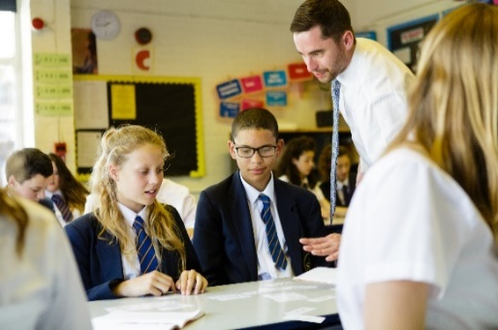

Feedback from teachers and GCSE exam analysis indicates there are key areas of the curriculum that students continue to find challenging. This Work Group will explore effective ways of teaching some of these topics, both to address the immediate needs of the incoming KS4 students, but also, crucially, taking a longer-term view by considering development in KS3.

The aim will be to get to grips with all the underpinning content of a topic, exploring misconceptions and effective pedagogical approaches for each element. The approaches also contribute towards the development of a generic process which departments could use as a ‘toolkit’ to lead the improvement of teaching and learning in any identified area of the curriculum students find challenging.

|  |
| --- |
| Overview |

Text here

**Who is this for?**

Secondary school maths teachers and heads of department. Participants in the 2018/19 Work Group are welcome to participate again.

**What is involved?**

Each Work Group will explore a single GCSE topic in depth. Participation will require attendance at four workshops spread across the year and include gap tasks. Any work produced will be shared across the hubs, giving access to a range of challenging topics.

Intended Outcomes

* Teachers will hone their ability to analyse what it is about certain topics that makes them more challenging, and be able to apply these analytical skills more widely in the curriculum.
* They will deepen their understanding and classroom practice in relation to teaching and learning styles most appropriate to effective learning in the particular topic area.
* Departments will have a model for improving the teaching and learning and curriculum provision for any area of the curriculum their students find challenging.
* Students in the participant teachers’ classes will become more confident in their own skills and abilities, developing a deeper and more connected understanding of prior content, thus enabling them to better tackle the challenging topics.

Challenging Topics at GCSE

**The wider context**

This national collaborative project focusses on one of the national maths education priority areas relating to ‘*supporting schools and colleges to address the immediate challenge of teaching GCSE Mathematics.’*

Each Maths Hub participating in a national project runs a local Work Group, where teachers come together over a period of time to work on areas defined by the project. All Work Groups are subject to a common evaluation process, which collectively provide a body of evidence on the project’s outcomes. So, your participation in this Work Group will contribute to your own professional leaning, and that of your school colleagues, as well as making a contribution to the improvement of maths education at a national level.

**If you’re interested, what next?**

Please email [NNWmathshub@queenkatherine.org](mailto:NNWmathshub@queenkatherine.org) to register your interest

**Expectations of participants and their schools**

* Attend the Work Group sessions and carry out a series of follow-up tasks within their own classrooms related to teaching the challenging topic being explored.
* Work with other members of their maths department, as appropriate, to develop the teaching of the challenging topic.

Hub to tailor according to Work Group design

* Contribute to Work Group evaluation processes.

**Funding**

There is no cost to schools for this work group and all sessions and resources are free of charge.

**Who is leading the Work Group?**

To be confirmed